JOIN
USE master;

-- =============================================
-- Database: JOINExample
-- =============================================
IF EXISTS
(
SELECT *
FROM sys.databases
WHERE name = N'JOINExample'
)
DROP DATABASE JOINExample
GO

CREATE DATABASE JOINExample;
GO

-- =============================================
-- Database: JOINExample
-- Table: Persons
-- =============================================
USE JOINExample;
GO

IF EXISTS
(
SELECT name
FROM sys.tables
WHERE name = 'Persons')
DROP TABLE Persons
GO

CREATE TABLE Persons
(
PersonID int NOT NULL,
FirstName varchar(20),
LastName varchar(20),
GenderID int
);
GO

INSERT
Persons
(
PersonID,
FirstName,
LastName,
GenderID
)
VALUES
(
1,
'Gertrude',
'Larson',
1
)

INSERT Persons
(
PersonID,
FirstName,
LastName
)
VALUES
(
2,
'Raymond',
'Kouma'
)

INSERT
Persons
(
PersonID,
FirstName,
LastName,
GenderID
)
VALUES
(
3,
'Peter',
'Mukuko',
2
)

INSERT
Persons
(
PersonID,
FirstName,
LastName,
GenderID
)
VALUES
(
4,
'Wally',
'Baston',
2
)

INSERT
Persons
(
PersonID,
FirstName,
LastName
)
VALUES
(
5,
'Sylvia',
'Nguyen'
)

INSERT
Persons
(
PersonID,
FirstName,
LastName,
GenderID
)
VALUES
(
6,
'Donald',
'Wallace',
2
)

INSERT
Persons
(
PersonID,
FirstName,
LastName,
GenderID
)
VALUES
(
7,
'Hermine',
'Kana',
1
)

INSERT
Persons
(
PersonID,
FirstName,
LastName
)
VALUES
(
8,
'Charlotte',
'Thomas'
)

INSERT
Persons
(
PersonID,
FirstName,
LastName
)
VALUES
(
9,
'Paula',
'Barbers'
)

INSERT
Persons
(
PersonID,
FirstName,
LastName,
GenderID
)
VALUES
(
10,
'Chrissie',
'Dentd',
3
)
GO

SELECT * FROM Persons

-- =============================================
-- Database: JOINExample
-- Table: Genders
-- =============================================
USE JOINExample;
GO

IF EXISTS
(
SELECT name
FROM sys.tables
WHERE name = 'Genders')
DROP TABLE Genders
GO

CREATE TABLE Genders
(
GenderID int,
Gender varchar(20)
);
GO

INSERT
Genders
(
GenderID,
Gender
)
VALUES
(
1,
'Female'
)

INSERT
Genders
(
GenderID,
Gender
)
VALUES
(
2,
'Male'
)

INSERT
Genders
(
GenderID,
Gender
)
VALUES
(
3,
'Unknown'
)
GO

INSERT
Genders
(
GenderID
)
VALUES
(
4
)
GO

INSERT
Genders
(
Gender
)
VALUES
(
'Undefined'
)
GO

SELECT * FROM Genders
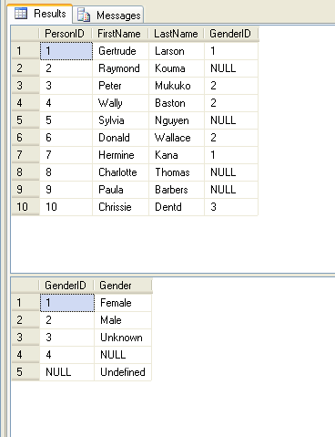
-- =============================================
-- Database: JOINExample
-- Table: Employees
-- =============================================
USE JOINExample;
GO

IF EXISTS
(
SELECT name
FROM sys.tables
WHERE name = 'Employees')
DROP TABLE Employees
GO

CREATE TABLE Employees
(
EmployeeID int NOT NULL,
EmployeeName varchar(20),
EmployeeManagerID int
);
GO

INSERT
Employees
(
EmployeeID,
EmployeeName
)
VALUES
(
1,
'Bill Gates'
)

INSERT
Employees
(
EmployeeID,
EmployeeName,
EmployeeManagerID
)
VALUES
(
2,
'Sergey Brin',
1
)

INSERT
Employees
(
EmployeeID,
EmployeeName,
EmployeeManagerID
)
VALUES
(
3,
'Steve Ballmer',
2
)

INSERT
Employees
(
EmployeeID,
EmployeeName,
EmployeeManagerID
)
VALUES
(
4,
'Larry Page',
3
)

INSERT
Employees
(
EmployeeID,
EmployeeName,
EmployeeManagerID
)
VALUES
(
5,
'Anders Hejlsberg',
4
)
GO

SELECT * FROM Employees
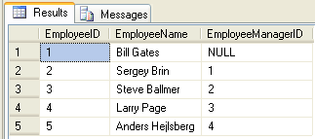

Types of Join:

Inner Join

- Self Join

- Natural Join

- Equi Join

Outer Join

- Left Outer Join

- Right Outer Join

- Full Outer Join

Cross Join

(INNER) JOIN

- SELF JOIN

SELECT E1.EmployeeName 'Manager', E2.EmployeeName 'Employee'
FROM Employees E1 JOIN Employees E2
ON E1.EmployeeID = E2.EmployeeManagerID
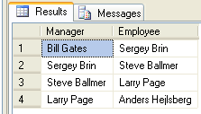

- Natural Join

SELECT Persons.*, Genders.Gender
FROM
Persons
JOIN
Genders
ON Persons.GenderID = Genders.GenderID

SELECT P.*, G.Gender
FROM
Persons P
JOIN
Genders G
ON P.GenderID = G.GenderID

SELECT P.PersonID, P.FirstName, P.LastName, P.GenderID, G.Gender
FROM
Persons P
JOIN
Genders G
ON P.GenderID = G.GenderID

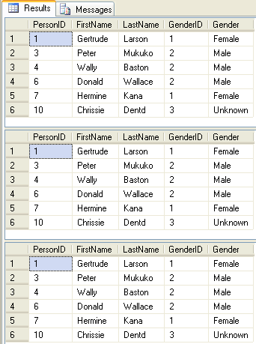

- Equi Join

SELECT *
FROM
Persons
JOIN
Genders
ON Persons.GenderID = Genders.GenderID

SELECT *
FROM
Persons
INNER JOIN
Genders
ON Persons.GenderID = Genders.GenderID

SELECT *
FROM
Persons P
INNER JOIN
Genders G
ON P.GenderID = G.GenderID
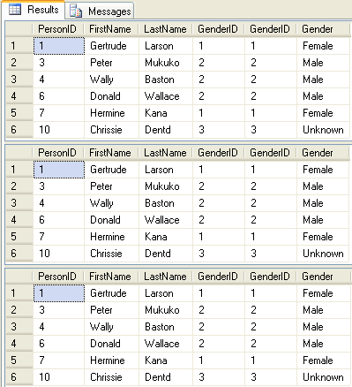

SELECT *
FROM
Genders
JOIN
Persons
ON Persons.GenderID = Genders.GenderID

SELECT *
FROM
Genders
INNER JOIN
Persons
ON Persons.GenderID = Genders.GenderID

SELECT *
FROM
Genders G
INNER JOIN
Persons P
ON P.GenderID = G.GenderID
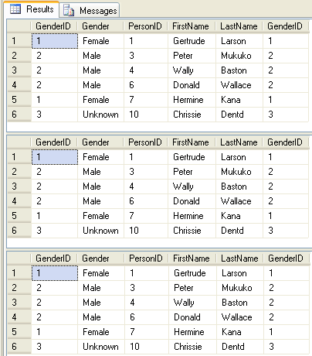

OUTER JOIN

- LEFT OUTER JOIN

SELECT *
FROM
Persons
LEFT OUTER JOIN
Genders
ON Persons.GenderID = Genders.GenderID
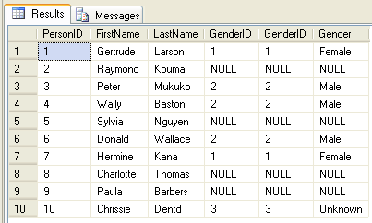

- RIGHT OUTER JOIN

SELECT *
FROM
Genders
RIGHT OUTER JOIN
Persons
ON Persons.GenderID = Genders.GenderID
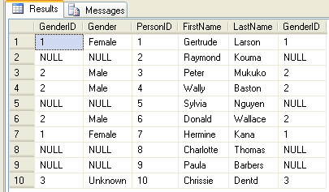
- LEFT OUTER JOIN

SELECT *
FROM
Genders
LEFT OUTER JOIN
Persons
ON Persons.GenderID = Genders.GenderID
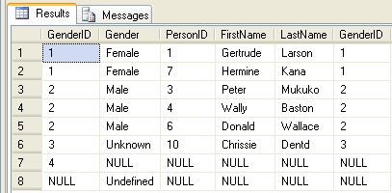

- RIGHT OUTER JOIN

SELECT *
FROM
Persons
RIGHT OUTER JOIN
Genders
ON Persons.GenderID = Genders.GenderID
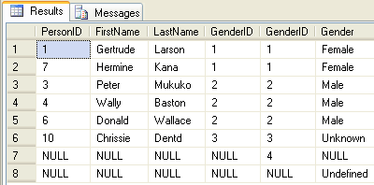

- FULL OUTER JOIN

SELECT *
FROM
Persons
FULL OUTER JOIN
Genders
ON Persons.GenderID = Genders.GenderID

SELECT *
FROM
Genders
FULL OUTER JOIN
Persons
ON Persons.GenderID = Genders.GenderID
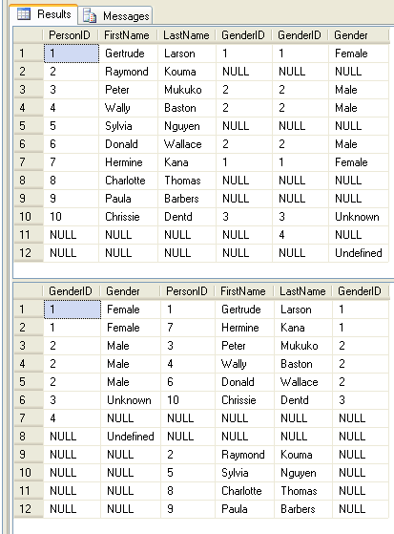

CROSS JOIN

SELECT *
FROM
Persons
CROSS JOIN
Genders
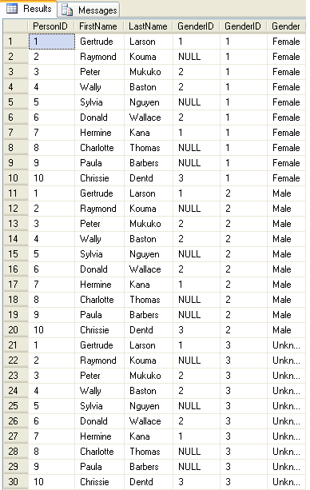
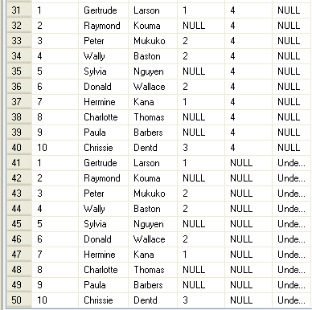

SELECT *
FROM
Genders
CROSS JOIN
Persons
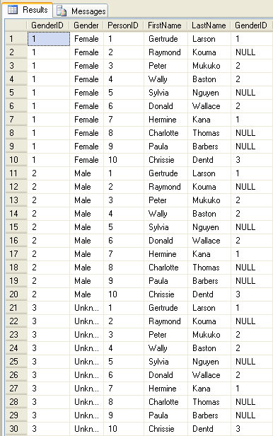
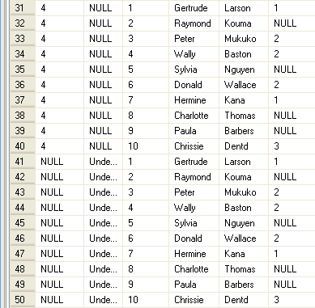

SELECT *
FROM
Persons
CROSS JOIN
Genders
WHERE Persons.GenderID = Genders.GenderID

SELECT *
FROM
Genders
CROSS JOIN
Persons
WHERE Persons.GenderID = Genders.GenderID

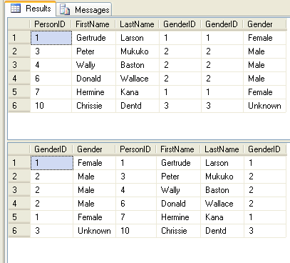

References:

http://functionx.com/sqlserver/Lesson15.htm

http://programming.top54u.com/post/Types-of-Joins-in-Sql-Server-2005.aspx

